

BACHELOR OF COMPUTER APPLICATIONS (BCA)

Seminar Report

BCA Sem VI

AY 2023-24

MICROSOFT AZURE

By

|  |  |  |
| --- | --- | --- |
| **Exam No.** | **Roll No.** | **Name of Student** |
| **5973** | **062** | **KAKADIYA DEEPKUMAR PRAVINBHAI** |

|  |  |
| --- | --- |
| Seminar Guide By : | |
| Dr . Brijal M. Panwala |  |

**Acknowledgement**

The success and final outcome of this seminar required a lot of guidance and assistance from many people and I am extremely fortunate to have got this all along the completion of my seminar work. Whatever I have done is only due to such guidance and assistance and I would not forget to thank them.

I owe our profound gratitude to our I/c Principal Dr. Aditi Bhatt, Trust representative & IQAC Coordinator Dr. Vaibhav Desai, Head of Department Dr. Vimal Vaiwala and Seminar guide Dr. Brijal M. Panwala and all other Assistant professors of SDJ International College, who took keen interest on my Seminar work and guided me all along, till the completion of my seminar work by providing all the necessary information for presenting a good Concept. I am extremely grateful to them for providing such a nice support and guidance though they had busy schedule managing the college affairs.

I am thankful and fortunate enough to get support and guidance from all Teaching staffs of Bachelor of Computer Application Department which helped me in successfully completing my seminar work. Also, I would like to extend my sincere regards to all the non-teaching staff of Bachelor of Computer Application Department for their timely support.

Deep Kakadiya ( 5973 )

I N D E X

|  |  |  |
| --- | --- | --- |
| **Sr No** | **Description** | **Page No.** |
| 1 | Overview of Topic | 1 |
| 2 | Introduction | 2 |
| 3 | Structure and Working | 15 |
| 4 | Advantage & Disadvantage | 17 |
| 5 | Conclusion | 21 |
| 6 | References | 22 |

1. **OVERVIEW OF THE TOPIC**

* What Is Microsoft Azure ?
* History Of Microsoft Azure.
* Purpose Of Microsoft Azure.
* How Microsoft Azure Work ?
* Microsoft Azure Phases.
* Example Of Microsoft Azure.
* Advantages Of Microsoft Azure.
* Disadvantages Of Microsoft Azure.
* Future Work Of Microsoft Azure.

1. **INTRODUCTION**

* Microsoft Azure is a comprehensive cloud computing platform offered by Microsoft. It provides a wide range of cloud services, including computing power, storage, networking, databases, machine learning, analytics, and more, to help individuals and organizations build, deploy, and manage applications and services through Microsoft's global network of data centers.
* Microsoft Azure offers a wide array of services including Virtual Machines, App Services, Storage, Databases, Cognitive Services, and more. As a leading cloud service provider, Azure's global network of data centers ensures the scalability and reliability of the services offered.
* Microsoft Azure, often simply referred to as Azure, is one of the leading cloud computing platforms in the world. It was launched by Microsoft in 2010 and has since grown to become a comprehensive suite of cloud services, catering to a diverse range of industries and use cases.
* As a cloud platform, Azure offers Infrastructure as a Service (IaaS), Platform as a Service (PaaS), and Software as a Service (SaaS) solutions, giving businesses the flexibility to choose the level of control and management they need for their applications and workloads.
* One of the key advantages of Azure is its global presence, with data centers located in multiple regions around the world. This allows businesses to deploy their applications closer to their end-users for reduced latency and improved performance, as well as to comply with data residency requirements.
* **HISTORY OF MICROSOFT AZURE.**
* Microsoft Azure, originally launched as Windows Azure in 2008, emerged as a pivotal component of Microsoft's cloud computing strategy. The platform's genesis stemmed from Microsoft's recognition of the transformative potential of cloud technology in the early 2000s.
* Positioned as a comprehensive cloud computing platform, Azure was designed to offer a wide range of services, including computing, storage, and networking, enabling developers and businesses to build, deploy, and manage applications and services in the cloud.
* In 2014, Microsoft rebranded the platform as Microsoft Azure, signaling its commitment to providing a broader set of services beyond the Windows ecosystem. Azure's evolution has been marked by significant expansions in its service offerings, global data center infrastructure, and strategic acquisitions aimed at enhancing its capabilities.
* The platform has embraced open-source technologies and fostered strong community engagement, positioning itself as a preferred cloud platform for enterprises across various industries. Microsoft's focus on research and innovation has driven advancements in areas such as artificial intelligence, IoT, and edge computing, further solidifying Azure's position as a leader in the cloud computing market alongside competitors like Amazon Web Services and Google Cloud Platform.
* Throughout its history, Microsoft Azure has remained dedicated to empowering businesses and developers with cutting-edge cloud technologies and solutions, reflecting Microsoft's commitment to driving digital transformation through cloud computing.

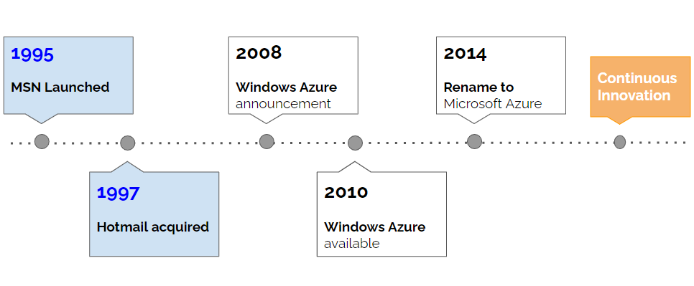

* **Initial Development (2006-2008)**
* Azure development began in 2006 under the codename "Project Red Dog" led by a team of Microsoft engineers including Dave Cutler.
* It was officially announced as "Windows Azure" during the Microsoft Professional Developers Conference in 2008.
* **Launch and Expansion (2009-2010)**
* Windows Azure was commercially launched on February 1, 2010.The platform initially offered services such as virtual machines, storage, and content delivery networks (CDN).
* As Azure gained traction, Microsoft continued to expand its offerings and data center locations.
* **Rebranding to Microsoft Azure (2014)**
* In March 2014, Microsoft announced the rebranding of Windows Azure to "Microsoft Azure" to reflect the broader scope of the platform beyond just Windows-based services.
* This rebranding aimed to emphasize Azure's support for various programming languages, frameworks, and operating systems.
* **Growing Ecosystem and Features (2015-2019)**
* Azure experienced rapid growth during this period, expanding its global footprint and adding new services regularly.Microsoft invested heavily in building data centers worldwide to support Azure's increasing demand.
* Key features and services introduced during this time include Azure Functions (serverless computing), Azure Cosmos DB (NoSQL database), Azure Machine Learning, and Azure DevOps.
* **Hybrid and Edge Computing (2019-present)**
* Microsoft focused on enabling hybrid cloud scenarios, allowing customers to seamlessly integrate on-premises infrastructure with Azure.Edge computing solutions like Azure IoT Edge were developed to extend Azure services to the edge of the network, enabling real-time data processing and analytics.
* Azure Arc was introduced, enabling customers to manage resources across on-premises, multi-cloud, and edge environments using Azure management tools.

 

* Microsoft first announced plans to launch Azure in 2008. Dave Cutler and Amitabh Srivastava are the lead developers of Azure.
* One of Srivastava's notable contributions was his involvement in the development of Microsoft Azure, the company's cloud computing platform.
* Azure was launched in 2010 and has since grown to become one of the leading cloud computing platforms in the world, offering a wide range of services including virtual machines, databases, analytics, and more.
* In the late 1980s, Cutler joined Microsoft where he led the development of Windows NT, a groundbreaking operating system that introduced many features still used in modern operating systems today.
* Cutler continued to work at Microsoft for many years, contributing to various projects including Windows 2000, Windows XP, and Windows Server.
* **PURPOSE OF MICROSOFT AZURE.**
* Microsoft Azure is a comprehensive cloud computing platform and set of services provided by Microsoft. Its purpose is to offer a wide range of cloud-based solutions to individuals, businesses, and organizations. Some key purposes of Microsoft Azure include:

1. **Infrastructure as a Service (IaaS)**

* Azure provides virtual machines, networking, and storage resources that allow users to build, deploy, and manage applications without investing in physical hardware.

1. **Platform as a Service (PaaS)**

* Azure offers a variety of platform services such as Azure App Service, Azure Functions, Azure SQL Database, and Azure Kubernetes Service (AKS), which enable developers to build, deploy, and scale applications more easily.

1. **Software as a Service (SaaS)**

* Azure hosts a wide range of pre-built software applications and services, including Microsoft 365, Dynamics 365, and various third-party applications, allowing users to access these applications over the internet without needing to install or manage them locally.

1. **Data Storage and Analytics**

* Azure provides various data storage solutions such as Azure Blob Storage, Azure SQL Database, Azure Cosmos DB, and Azure Data Lake Storage, along with analytics services like Azure Synapse Analytics and Azure Databricks, enabling users to store, manage, analyze, and gain insights from their data.

1. **Artificial Intelligence (AI) and Machine Learning (ML)**

* Azure offers AI and ML services such as Azure Cognitive Services, Azure Machine Learning, and Azure Databricks, empowering developers to build intelligent applications and perform advanced analytics tasks.

1. **Internet of Things (IoT)**

* Azure IoT Hub and Azure IoT Central are services that enable users to connect, monitor, and manage IoT devices and solutions securely at scale.

1. **Security and Compliance**

* Azure provides a range of security services and compliance certifications, helping users protect their data and meet regulatory requirements.

1. **DevOps and Developer Tools**

* Azure DevOps, Azure Pipelines, and Visual Studio Team Services (VSTS) are tools and services provided by Azure to support collaboration, automation, and continuous integration/continuous deployment (CI/CD) processes for software development and deployment.
* **MICROSOFT AZURE PHASES.**
* Microsoft Azure, like many cloud computing platforms, involves several phases or key components in its operation. These phases can be broadly categorized as follows.
* **All Phases Of Microsoft Azure.**

1. **Planning and Design**

* This initial phase involves assessing the organization's requirements, defining goals, and designing the architecture of the Azure solution. It includes identifying workloads to migrate or deploy, choosing appropriate Azure services, designing network and security configurations, and planning for scalability and high availability.

1. **Deployment**

* Once the planning and design are complete, the deployment phase involves provisioning and configuring resources in Azure according to the design. This may include creating virtual machines, setting up networking components like virtual networks and subnets, configuring storage solutions, and deploying applications or workloads onto Azure.

1. **Management and Monitoring**

* After deployment, ongoing management and monitoring of the Azure environment are essential to ensure optimal performance, security, and cost-efficiency. This phase involves tasks such as monitoring resource usage and performance metrics, managing access and permissions, implementing security measures like identity and access management (IAM), and optimizing resource utilization to control costs.

1. **Scaling and Optimization**

* As the organization's needs evolve, the Azure environment may need to scale up or down to accommodate changing workloads or requirements. This phase involves dynamically adjusting resources to meet demand, optimizing configurations for performance and cost-effectiveness, and implementing automation to streamline operations and improve efficiency.

1. **Security and Compliance**

* Ensuring the security and compliance of the Azure environment is a critical phase that involves implementing robust security measures, such as network security groups, encryption, and identity management, to protect data and resources. It also involves maintaining compliance with regulatory requirements and industry standards through features like Azure Security Center and Azure Policy.

1. **Backup and Disaster Recovery**

* Backup and disaster recovery are essential aspects of Azure's operation to protect against data loss and ensure business continuity. This phase involves implementing backup solutions for data and applications, configuring disaster recovery plans using services like Azure Site Recovery, and regularly testing and validating recovery procedures.

1. **Continuous Improvement**

* The final phase involves continuously evaluating and improving the Azure environment to optimize performance, reliability, and cost efficiency. This may include conducting regular reviews of architecture and configurations, implementing best practices and recommendations from Azure's documentation and resources, and incorporating feedback from users and stakeholders to drive ongoing improvements.
* **EXAMPLE OF MICROSOFT AZURE.**

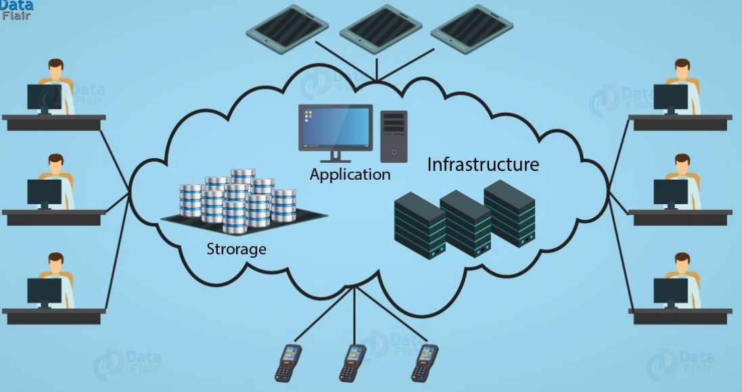

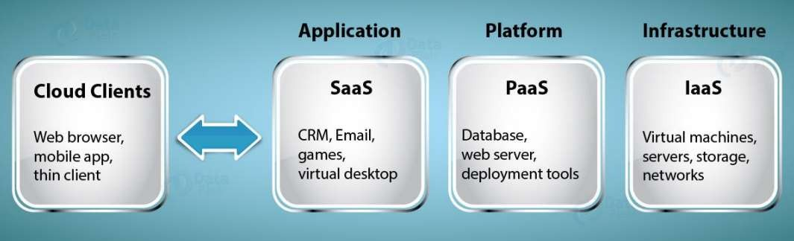

* **Infrastructure as a service(IAAS)**
* IaaS provides the user the ability provision computing and storage resources.
* These resources are provided to the users as virtual machine instances and virtual storage.
* Users can start, stop configure and manage the virtual machines instance on the virtual storage using can deploy operating systems and applications on their choice on the actual resources provisions in the cloud .
* Cloud Service Provider manages the underlying infrastructure.
* **Platform as a service(PaaS)**
* platform as a service provides the user the ability to develop and deploy application in the cloud using the deployment tool application programming interfaces API, software libraries and services provided by the Cloud Service Provider.
* The Cloud Service Provider manages the underlying cloud infrastructure including servers, network, operating systems and storage .
* **Software as a service(SaaS)**
* Provide the user a complete software applications of the user interface to the application itself . The Cloud Service Provider manage the underlying cloud infrastructure including server, network storage and application software, and the user is unaware of the underlying architecture of the cloud.
* Applications are provided to the user through a thin client interface example Browser application.
* SaaS applications are accessed from various client smart phones running different operating system.
* **FUTURE WORK OF MICROSOFT AZURE.**
* As of my last update in January 2022, I can't provide specific details on future developments or projects within Microsoft Azure beyond that point. However, Microsoft Azure, like many other cloud computing platforms, is continuously evolving to meet the changing needs of its users and to incorporate advancements in technology.
* Some general areas where Microsoft Azure may continue to focus on or expand in the future include

**1. Hybrid Cloud Solutions**

* Azure has been emphasizing hybrid cloud solutions, allowing businesses to integrate on-premises infrastructure with cloud services. This trend may continue as more businesses adopt hybrid cloud strategies for flexibility and scalability.

**2. AI and Machine Learning**

* Azure offers various AI and machine learning services, including Azure Machine Learning and Azure Cognitive Services. Microsoft may continue to invest in these areas to enhance capabilities and offer more advanced AI solutions to customers.

**3. IoT (Internet of Things)**

* Azure IoT services enable businesses to connect, monitor, and manage IoT devices. As the IoT market continues to grow, Microsoft may introduce new services and features to support IoT deployments at scale.

**4. Edge Computing**

* Edge computing brings computation and data storage closer to the location where it is needed, reducing latency and bandwidth usage. Azure has been investing in edge computing solutions, and this trend may continue as edge computing becomes more prevalent.

**5. Security and Compliance**

* Security and compliance are critical concerns for businesses moving to the cloud. Azure provides various security services and compliance certifications. Microsoft may continue to enhance security features and obtain additional certifications to meet the needs of customers in regulated industries.

**6. Containerization and Kubernetes**

* Azure offers container services like Azure Kubernetes Service (AKS) for deploying, managing, and scaling containerized applications. Microsoft may continue to invest in containerization technologies and provide additional tools to simplify container orchestration and management.

**7. Serverless Computing**

* Azure provides serverless computing services like Azure Functions, allowing developers to build and run applications without managing infrastructure. Microsoft may expand its serverless offerings and improve integration with other Azure services.

**8. Quantum Computing**

* Microsoft has been investing in quantum computing research and development through Azure Quantum. While quantum computing is still in its early stages, Microsoft may continue to explore and develop quantum computing technologies.

1. **STRUCTURE AND WORKING**

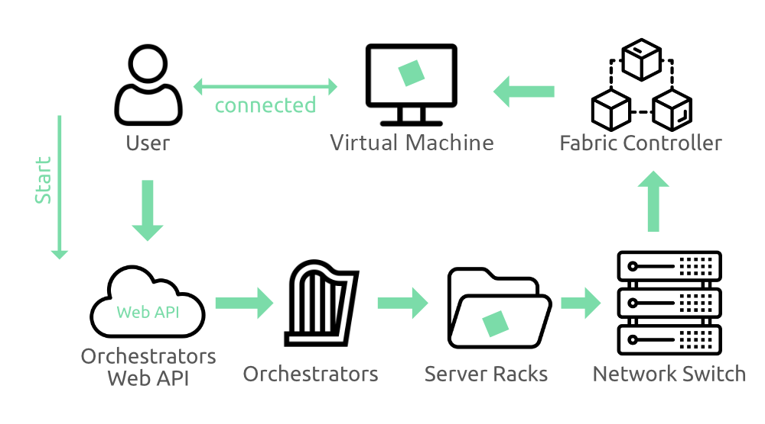

* Microsoft Azure is a cloud computing platform that provides a wide range of services to help organizations build, deploy, and manage applications and services through Microsoft-managed data centers. The process you described involves several layers of Azure's infrastructure and services working together to deliver computing resources to users. Let's break down each component:

**1. User**

* This refers to anyone who interacts with Azure, such as developers, IT professionals, or administrators. Users access Azure services through a web-based portal, command-line interface (CLI), or application programming interfaces (APIs).

**2. Orchestrators**

* In Azure, orchestrators are responsible for managing and coordinating various tasks and resources within the cloud environment. This includes tasks like provisioning virtual machines, scaling resources based on demand, and managing deployments. Azure offers several orchestrators, including Azure Resource Manager (ARM).

**3. Web API**

* The Web API allows users to interact with Azure services programmatically. It provides a set of HTTP endpoints that users can call to perform tasks such as provisioning resources, managing deployments, or retrieving information about Azure services.

**4. Server Racks**

* Azure data centers consist of thousands of server racks that house the physical hardware required to run virtual machines, store data, and provide networking services. Each server rack contains multiple servers, storage devices, and networking equipment.

**5. Network Switch**

* Network switches connect the servers within a data center and allow them to communicate with each other. They also provide connectivity to other parts of the Azure infrastructure, such as storage systems and virtual machines.

1. **Fabric Controller**

* The Fabric Controller is a core component of Azure's infrastructure that manages the allocation and utilization of resources within the data center. It oversees tasks such as provisioning virtual machines, managing storage resources, and ensuring high availability of services.

1. **Virtual Machine**

* Virtual machines (VMs) are the basic building blocks of Azure's compute services. They are software-based representations of physical servers and can run various operating systems and applications. Users can deploy and manage VMs in Azure to host their applications or workloads.

1. **ADVANTAGES & DISADVANTAGES**

**ADVANTAGES**

* Microsoft Azure, as one of the leading cloud computing platforms, offers a wide range of advantages for businesses and developers.

**1. Scalability**

* Azure allows businesses to easily scale their resources up or down based on demand, enabling them to handle varying workloads efficiently. This scalability is particularly useful for businesses experiencing seasonal fluctuations or sudden spikes in traffic.

**2. Global Presence**

* With data centers located in regions around the world, Azure provides global coverage, enabling businesses to deploy their applications closer to their users for lower latency and improved performance.

**3. Security and Compliance**

* Azure offers robust security features and compliance certifications, helping businesses meet various regulatory requirements and ensuring the protection of their data. Microsoft invests heavily in security measures such as encryption, threat detection, and identity management.

**4. Hybrid Capabilities**

* Azure supports hybrid cloud deployments, allowing businesses to integrate their on-premises infrastructure with Azure's public cloud services seamlessly. This flexibility enables organizations to leverage their existing investments while taking advantage of the scalability and innovation of the cloud.

**5. Integration with Microsoft Products**

* Azure seamlessly integrates with other Microsoft products and services such as Office 365, Dynamics 365, and Windows Server, providing a cohesive ecosystem for businesses that already use Microsoft technologies.

**6. Cost-Effective Pricing**

* Azure offers various pricing options, including pay-as-you-go, reserved instances, and hybrid benefits, allowing businesses to optimize their costs based on usage and budget requirements.

**7. Extensive Service Offerings**

* Azure provides a wide range of services, including compute, storage, networking, databases, analytics, machine learning, Internet of Things (IoT), artificial intelligence (AI), and more. This breadth of services caters to diverse business needs and allows developers to build and deploy applications with ease.

**8. DevOps and Developer Tools**

* Azure offers comprehensive DevOps tools and services, such as Azure DevOps, Azure Pipelines, and Azure Kubernetes Service (AKS), facilitating collaboration, automation, and continuous integration/continuous deployment (CI/CD) processes for developers.

**9. AI and Machine Learning**

* Azure's AI and machine learning services, such as Azure Machine Learning and Azure Cognitive Services, enable businesses to leverage advanced analytics, natural language processing, computer vision, and predictive modeling to derive valuable insights and enhance their applications.

**10. Community and Support**

* Microsoft Azure has a large and active community of developers, partners, and experts who contribute to knowledge sharing, best practices. resources, making it easier for businesses to adopt and succeed with the platform.

**DISADVANTAGES**

* While Microsoft Azure offers numerous benefits, there are also some potential drawbacks or challenges that businesses should consider.

**1. Complexity**

* Azure's extensive range of services and features can sometimes lead to complexity, especially for organizations with limited cloud expertise. Managing and optimizing resources effectively may require specialized skills and training.

**2. Cost Management**

* While Azure offers various pricing options, managing costs can be challenging, particularly for organizations with fluctuating workloads or inefficient resource usage. Without proper monitoring and optimization, cloud expenses can escalate quickly.

**3. Vendor Lock-In**

* Choosing Azure as a cloud provider may result in vendor lock-in, making it difficult to migrate applications and data to other platforms in the future. Businesses should carefully consider the long-term implications of vendor lock-in when selecting a cloud provider.

**4. Latency and Performance**

* Although Azure has a global network of data centers, latency and performance can still be issues, especially for applications that require real-time processing or data transfer across regions. Businesses with specific latency requirements should evaluate Azure's performance relative to their needs.

**5. Limited Availability Zones in Some Regions**

* While Azure continues to expand its global footprint, not all regions have multiple availability zones, which can impact high availability and disaster recovery strategies for businesses operating in those regions.

**6. Learning Curve for New Technologies**

* Azure regularly introduces new technologies and services, which may require time and effort for businesses to understand and adopt. Keeping up with the pace of innovation in the Azure ecosystem can be challenging for some organizations.

**7. Potential Downtime and Outages**

* Despite robust infrastructure and redundancy measures, Azure, like any cloud platform, can experience downtime or outages. Businesses should have contingency plans in place to mitigate the impact of service interruptions on their operations.

**8. Security and Compliance Concerns**

* While Azure provides robust security features, businesses are ultimately responsible for implementing appropriate security measures and ensuring compliance with industry regulations. Data breaches or compliance violations can have significant consequences for organizations using Azure.

**9. Dependence on Third-Party Integrations**

* Azure's ecosystem relies on third-party integrations and partnerships for certain services and functionalities. Businesses should consider the potential impact of dependencies on third-party providers when evaluating Azure for their needs.

**10. Support and Documentation**

* While Azure offers extensive documentation and support resources, some users may find it challenging to navigate and find relevant information. Additionally, the quality and responsiveness of support can vary depending on the level of service and support plan chosen by the organization.

1. **CONCLUSION**

* In conclusion, Microsoft Azure offers a comprehensive and feature-rich cloud computing platform with numerous advantages, including scalability, global presence, security, hybrid capabilities, integration with Microsoft products, cost-effective pricing, extensive service offerings, DevOps and developer tools, AI and machine learning capabilities, and a vibrant community.
* However, businesses should also be aware of potential disadvantages such as complexity, cost management challenges, vendor lock-in, latency and performance issues in some regions, limited availability zones, learning curve.
* for new technologies, potential downtime and outages, security and compliance concerns, dependence on third-party integrations, and support/documentation considerations.
* Despite these challenges, Microsoft Azure remains a compelling choice for businesses seeking innovation, agility, and scalability in the cloud, provided they carefully evaluate their needs, consider the pros and cons, and implement appropriate strategies to maximize the benefits of the platform while mitigating potential risks.
* With proper planning and execution, Microsoft Azure can empower organizations to drive digital transformation, enhance productivity, and achieve their business objectives in a dynamic and competitive landscape.
* Ultimately, Microsoft Azure empowers businesses to innovate, scale, and optimize their operations in a rapidly evolving digital landscape.
* Azure offers businesses the tools and capabilities they need to thrive in today's dynamic business environment.

1. **REFERENCES**

1. ARCHITECTURE :

* <https://learn.microsoft.com/en-us/azure/architecture/guide/aks/aks-cicd-azure-pipelines>

2. HISTORY :

* <https://techcommunity.microsoft.com/t5/educator-developer-blog/the-history-of-microsoft-azure/ba-p/3574204>

3. EXAMPLE :

* <https://azure.microsoft.com/en-in>